NEPAL COLLEGE OF INFORMATION TECHNOLOGY
Balkumari, Lalitpur
Affiliated to Pokhara University

LAB REPORT FOR EMBEDDED SYSTEMS


LAB REPORT 8: VHDL CODE FOR ENCODER & DECODER

Submitted by: Submitted to:
Name: Arpan Adhikari Er. Simanta Kasaju Roll No.: 231309
BE-CE (5th SEM)

S. N | LAB TOPIC | DATE | REMARKS
1. | VHDL Code (OR & AND Gate) | 20th Nov, 2025
2. | VHDL Code (OR & NOT Gate) using testbench | 23rd Nov
3. | Universal Gates and Special Gates | 30th Nov
4. | VHDL Code for Adder | 7th Dec
5. | VHDL Code for Subtractor | 14th Dec
6. | VHDL Code for Multiplexer | 21st Dec
7. | VHDL Code for De-Multiplexer | 4th Jan,  2026
8. | VHDL Code for Decoder and Encoder | 18th Jan

LAB 8: VHDL CODE FOR DECODER AND ENCODER

Objective
The objective of this experiment is to design and implement a 3:8 Decoder and an 8:3 Encoder using VHDL. The aim is to understand the working of combinational logic circuits that perform data expansion and data compression. This experiment also helps in learning how to describe hardware using VHDL, simulate the designs, and verify their functionality using truth tables.

Theory

3:8 Decoder
A 3:8 decoder is a combinational logic circuit that converts 3 binary input lines into 8 output lines. For each unique input combination, only one output line is activated (logic HIGH), while all other outputs remain LOW. Thus, it performs binary-to-one-hot code conversion.
A 3:8 decoder has three inputs (A₂, A₁, A₀) and eight outputs (Y₀ to Y₇). The active output corresponds to the binary value of the input. Since the decoder is a combinational circuit, its output depends only on the present input values.
3:8 decoders are widely used in memory address decoding, instruction decoding, data selection, and digital control circuits.

Truth Table of 3:8 Decoder
A₂ | A₁ | A₀ | Y₇ | Y₆ | Y₅ | Y₄ | Y₃ | Y₂ | Y₁ | Y₀
0 | 0 | 0 | 0 | 0 | 0 | 0 | 0 | 0 | 0 | 1
0 | 0 | 1 | 0 | 0 | 0 | 0 | 0 | 0 | 1 | 0
0 | 1 | 0 | 0 | 0 | 0 | 0 | 0 | 1 | 0 | 0
0 | 1 | 1 | 0 | 0 | 0 | 0 | 1 | 0 | 0 | 0
1 | 0 | 0 | 0 | 0 | 0 | 1 | 0 | 0 | 0 | 0
1 | 0 | 1 | 0 | 0 | 1 | 0 | 0 | 0 | 0 | 0
1 | 1 | 0 | 0 | 1 | 0 | 0 | 0 | 0 | 0 | 0
1 | 1 | 1 | 1 | 0 | 0 | 0 | 0 | 0 | 0 | 0

8:3 Encoder
An 8:3 encoder is a combinational logic circuit that converts eight input lines into a 3-bit binary output. Only one input is assumed to be active at a time, and the output represents the binary equivalent of the active input line. Hence, an encoder performs data compression.
An 8:3 encoder has eight inputs (D₀ to D₇) and three outputs (A₂, A₁, A₀). When a particular input line is HIGH, the encoder produces the corresponding 3-bit binary code at the output. The circuit has no memory and does not require a clock signal.
8:3 encoders are commonly used in keyboard encoding, priority encoding, interrupt systems, and digital communication circuits.

Truth Table of 8:3 Encoder
D₇ | D₆ | D₅ | D₄ | D₃ | D₂ | D₁ | D₀ | A₂ | A₁ | A₀
0 | 0 | 0 | 0 | 0 | 0 | 0 | 1 | 0 | 0 | 0
0 | 0 | 0 | 0 | 0 | 0 | 1 | 0 | 0 | 0 | 1
0 | 0 | 0 | 0 | 0 | 1 | 0 | 0 | 0 | 1 | 0
0 | 0 | 0 | 0 | 1 | 0 | 0 | 0 | 0 | 1 | 1
0 | 0 | 0 | 1 | 0 | 0 | 0 | 0 | 1 | 0 | 0
0 | 0 | 1 | 0 | 0 | 0 | 0 | 0 | 1 | 0 | 1
0 | 1 | 0 | 0 | 0 | 0 | 0 | 0 | 1 | 1 | 0
1 | 0 | 0 | 0 | 0 | 0 | 0 | 0 | 1 | 1 | 1

Encoder and Decoder Using VHDL
Both the 3:8 decoder and 8:3 encoder are implemented in VHDL as combinational circuits using case or conditional statements. VHDL allows easy modeling, simulation, and verification of these circuits before hardware implementation, making it suitable for digital system design.

3:8 DECODER

DATAFLOW:
library IEEE;
use IEEE.std_logic_1164.all;

Entity arp_decoder is
port(
I : in std_logic_vector(2 downto 0);
Y : out std_logic_vector(7 downto 0)
);
end arp_decoder;

architecture arch_arpdecoder of arp_decoder is
begin
Y(0) <= (not I(2)) and (not I(1)) and (not I(0));
Y(1) <= (not I(2)) and (not I(1)) and ( I(0));
Y(2) <= (not I(2)) and ( I(1)) and (not I(0));
Y(3) <= (not I(2)) and ( I(1)) and ( I(0));
Y(4) <= ( I(2)) and (not I(1)) and (not I(0));
Y(5) <= ( I(2)) and (not I(1)) and ( I(0));
Y(6) <= ( I(2)) and ( I(1)) and (not I(0));
Y(7) <= ( I(2)) and ( I(1)) and ( I(0));
end arch_arpdecoder;
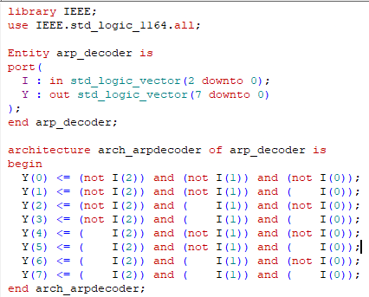
BEHAVIORAL:

library IEEE;
use IEEE.std_logic_1164.all;

Entity arp_decoder is
port(
I : in std_logic_vector(2 downto 0);
Y : out std_logic_vector(7 downto 0)
);
end arp_decoder;

architecture arch_arpdecoder of arp_decoder is
begin
process(I)
begin
case I is
when "000" => Y <= "00000001";
when "001" => Y <= "00000010";
when "010" => Y <= "00000100";
when "011" => Y <= "00001000";
when "100" => Y <= "00010000";
when "101" => Y <= "00100000";
when "110" => Y <= "01000000";
when "111" => Y <= "10000000";
when others => Y <= "00000000";
end case;
end process;
end arch_arpdecoder;

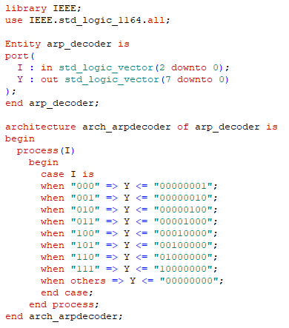

TESTBENCH:

library IEEE;
use IEEE.std_logic_1164.all;

entity test_arpdecoder is
end test_arpdecoder;

architecture arp_behavioral of test_arpdecoder is
component arp_decoder
port(
I : in std_logic_vector(2 downto 0);
Y : out std_logic_vector(7 downto 0)
);
end component;

signal I : std_logic_vector(2 downto 0);
signal Y : std_logic_vector(7 downto 0);

begin

UUT: arp_decoder port map (
I => I,
Y => Y
);

stim_proc : process
begin
I <= "000"; wait for 100 ps;
I <= "001"; wait for 100 ps;
I <= "010"; wait for 100 ps;
I <= "011"; wait for 100 ps;
I <= "100"; wait for 100 ps;
I <= "101"; wait for 100 ps;
I <= "110"; wait for 100 ps;
I <= "111"; wait for 100 ps;
end process;
end arp_behavioral;

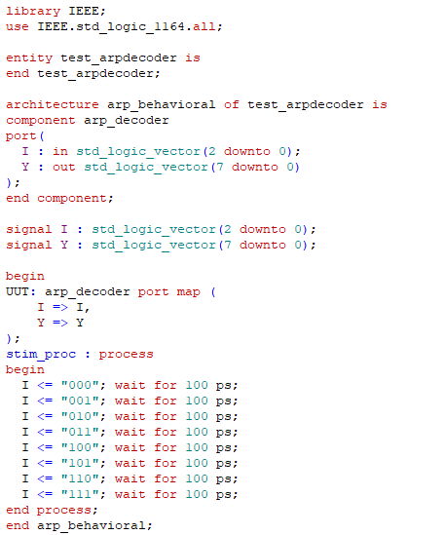

WAVEFORM:

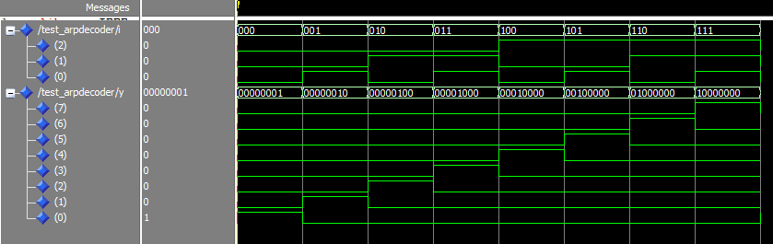

8:3 ENCODER

DATAFLOW:

library IEEE;
use IEEE.std_logic_1164.all;

entity arp_encoder is
port(
D : in std_logic_vector(7 downto 0);
A : out std_logic_vector(2 downto 0)
);
end arp_encoder;

architecture arch_arpencoder of arp_encoder is
begin
A(2) <= D(4) or D(5) or D(6) or D(7);
A(1) <= D(2) or D(3) or D(6) or D(7);
A(0) <= D(1) or D(3) or D(5) or D(7);
end arch_arpencoder;

BEHAVIORAL:

library IEEE;
use IEEE.std_logic_1164.all;

entity arp_encoder is
port(
D : in std_logic_vector(7 downto 0);
A : out std_logic_vector(2 downto 0)
);
end arp_encoder;

architecture arch_arpencoder of arp_encoder is
begin
process(D)
begin
case D is
when "00000001" => A <= "000";
when "00000010" => A <= "001";
when "00000100" => A <= "010";
when "00001000" => A <= "011";
when "00010000" => A <= "100";
when "00100000" => A <= "101";
when "01000000" => A <= "110";
when "10000000" => A <= "111";
when others => A <= "000";
end case;
end process;
end arch_arpencoder;

TESTBENCH:

library IEEE;
use IEEE.std_logic_1164.all;

entity test_arpencoder is
end test_arpencoder;

architecture arp_behavioral of test_arpencoder is

component arp_encoder
port(
D : in std_logic_vector(7 downto 0);
A : out std_logic_vector(2 downto 0)
);
end component;

signal D : std_logic_vector(7 downto 0);
signal A : std_logic_vector(2 downto 0);

begin

UUT: arp_encoder port map (
D => D,
A => A
);

stim_proc : process
begin
D <= "00000001"; wait for 100 ps;
D <= "00000010"; wait for 100 ps;
D <= "00000100"; wait for 100 ps;
D <= "00001000"; wait for 100 ps;
D <= "00010000"; wait for 100 ps;
D <= "00100000"; wait for 100 ps;
D <= "01000000"; wait for 100 ps;
D <= "10000000"; wait for 100 ps;
end process;

end arp_behavioral;
WAVEFORM:
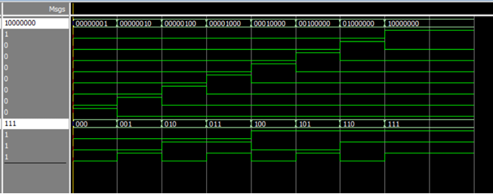

Result
The 3:8 Decoder and 8:3 Encoder were successfully designed and simulated using VHDL. The simulation outputs matched the expected truth tables. The decoder activated the correct single output for each input combination, and the encoder generated the correct binary code for each active input.

Conclusion
The experiment successfully demonstrated the design and verification of combinational circuits using VHDL. The 3:8 decoder performed correct data expansion, and the 8:3 encoder performed correct data compression. This experiment helped in understanding dataflow and behavioral modeling in VHDL.

